
MALAWI UNIVERSITY OF BUSINESS AND APPLIED SCIENCE
FACULTY OF APPLIED SCIENCES
DEPARTMENT OF INFORMATION TECHNOLOGY

COURSE : CIT-HCI-411
TITLE : MyAfrimax App
SUBMITTED TO : Mr. R Banda
SUBMITTED BY : DEFTON MAKWALE
REGISTRATION NO : BIS/22/EP/015
YEAR : 2026
DUE DATE : 10 April 2026

Table of Contents
1. System Selection & Description 3
1.1 System Selected 3
1.2 Purpose of the System 3
1.3 Primary Users 3
1. Field Observation & Data Collection 3
2.1 Methodology 3
2.2 User 1 — Michael Kachere 4
2.2.1 Task Observation — Michael 4
2.2.2 Interview Responses — Michael 4
2.3 User 2 — Daniel Ngwira 5
2.3.1 Task Observation — Daniel 5
2.3.2 Interview Responses — Daniel 5
2.4 Evidence (Photographic Documentation) 6
2. Usability Analysis Using HCI Principles 7
Principle 1: Feedback 7
Principle 2: Consistency 7
Principle 3: Efficiency of Use 8
Principle 4: Error Prevention 8
3. Task Analysis — Hierarchical Task Analysis (HTA) 9
Key Task: Purchasing a Data Bundle via MyAfrimax App 9
4.2. Where Users Struggle Most 10
4. Redesign: Proposed Improved System 11
5.1 Design Philosophy 11
5.2 Before vs After Comparison 11
5.3 Redesign Changes Explained 11
5.4 Low-Fidelity Prototype Description 12
5. Reflection & Evaluation 12
6.1 What I Learned 12
6.2 What Surprised Me About User Behavior 13
6.3 Why User-Centered Design Is Important 13

System Selection & Description

1.1 System Selected
The system selected for this HCI assignment is the MyAfrimax Mobile application a customer-facing mobile application developed by Afrimax Internet Services for their subscribers in Malawi.

1.2 Purpose of the System
MyAfrimax is designed to serve as a self-service portal that allows Afrimax internet customers to manage their internet service accounts directly from their smartphones. The application enables users to:
- View available data plans and their pricing in MWK
- Check current data usage (Anytime Data and NightShift Data balances)
- Initiate data bundle purchases
- Process payments via the Airtel Money mobile money platform
- Refresh account balance information
However, a significant limitation exists where payment completion requires the user to manually switch to the Airtel Money USSD system (dialing *211#) and navigate through 9 manual steps. There is no automatic data transfer between the two platforms.

1.3 Primary Users
The primary users of the MyAfrimax application include:
- Students and adults who rely on mobile internet for academic and social use
- Small business owners who use Afrimax internet for business operations
- Residential home users who subscribe to Afrimax broadband services
- Airtel Money account holders who use mobile money for payments

Field Observation & Data Collection

2.1 Methodology
A real usability study was conducted involving two active MyAfrimax users. The observation sessions took place in a natural setting both participants were at home and were asked to complete a standard task including purchasing a data bundle using the MyAfrimax app. The following data was recorded during each session:
- Tasks attempted by the user
- Difficulties and errors encountered
- Time taken to complete key steps
- Post-task interview responses (3 questions per user)

2.2 User 1 — Michael Kachere
Name | Michael Kachere
Age | 25
Occupation | University Student
Email | mkachere@gmail.com
App Usage Duration | 4+ months

2.2.1 Task Observation — Michael
Michael was asked to purchase the Special Pro-10 bundle (10 GB, MWK 2,500). He navigated to the Discover tab, browsed to the Data Plans screen, selected the bundle and proceeded to the payment page. He selected the Airtel Money option and tapped “Process.” At this point, the app displayed the Airtel Money Procedure screen a 9-step manual guide. Michael read through it slowly, appeared confused and had to re-read steps multiple times before dialing *211#.
- Time to reach payment screen: 1 minute 10 seconds
- Time spent reading the 9-step manual process: 3 minutes 30 seconds
- Total task completion time: 4 minutes
- Errors made: Dialed the wrong code initially, had to retry

2.2.2 Interview Responses — Michael
Question | Response
What was difficult? | Having to manually dial *211# and go through all 9 steps was very frustrating. The app should handle that automatically.
What confused you? | The step-by-step USSD instructions were hard to follow while also trying to switch between the app and the dialer.
What would you improve? | I would add an in-app payment that directly connects to Airtel Money so I don’t need to leave the app.

2.3 User 2 — Daniel Ngwira
Name | Daniel Ngwira
Age | 20
Occupation | University Student
Email | dngwira@gmail.com
App Usage Duration | 4 years (expert user)

2.3.1 Task Observation — Daniel
Daniel is a long-time user with 4 years of experience on the platform. He completed the bundle purchase task more quickly but encountered a different issue. The app displayed a price of MWK 2,500 for the Special Pro-10 bundle on the Data Plans screen, however the actual deduction from his Airtel Money wallet during a previous transaction was MWK 2,600 (inclusive of transaction fees not shown upfront). He flagged this as a persistent trust issue with the application.
- Time to complete purchase task: 1 minutes
- Errors made: None but noted pricing discrepancy
- Key issue: Lack of transparent fee disclosure before payment confirmation

2.3.2 Interview Responses — Daniel
Question | Response
What was difficult? | The transition from the app to Airtel Money USSD is still manual even after 4 years. Nothing has changed.
What confused you? | The price shown in the app does not include the Airtel transaction fee. I only know this because I’ve used it for years.
What would you improve? | Show the total cost including fees before I confirm. Also, integrate payment so I don’t have to do 9 steps manually.

2.4 Evidence (Photographic Documentation)
Below are placeholders for two screenshots captured during the observation sessions. These images document the actual MyAfrimax app screens as experienced by the users during testing.
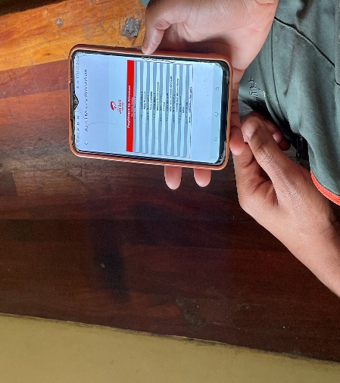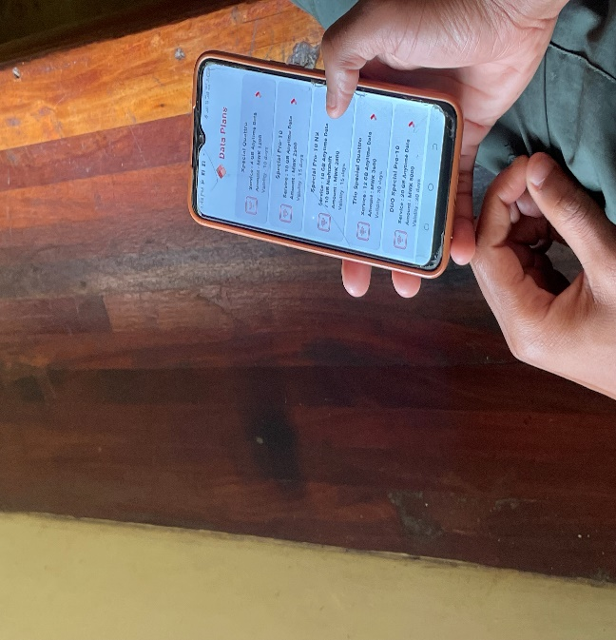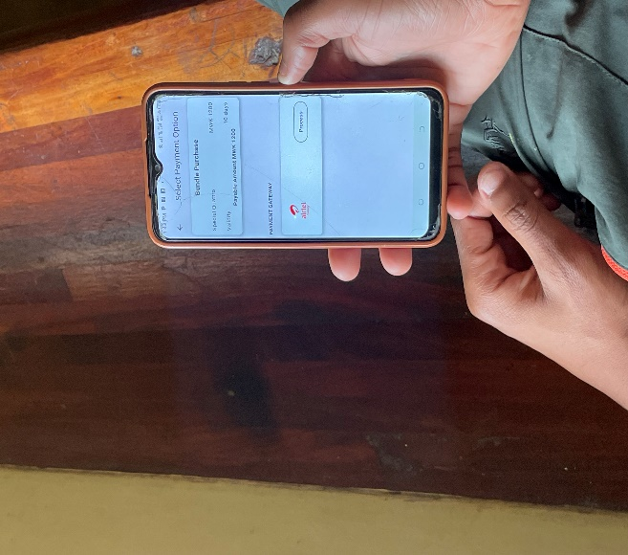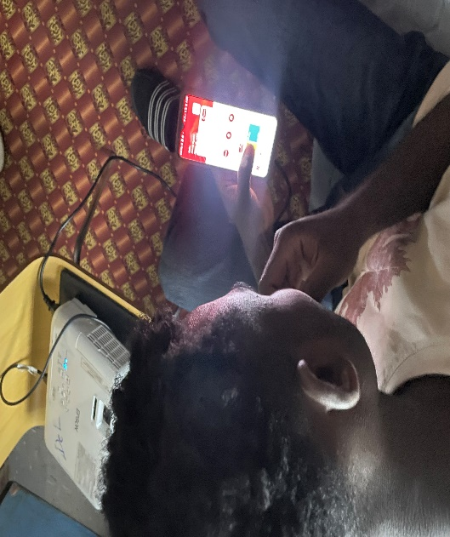

Usability Analysis Using HCI Principles
The following section analyzes the MyAfrimax application against four core HCI principles. Each principle is linked to a specific observed usability problem with real examples from the field study.

Principle 1: Feedback
Definition: The system should always keep users informed about what is happening through appropriate, timely feedback.

Usability Problem | When a user presses “Process” on the payment page, the app does not initiate any payment, it simply displays a 9-step manual USSD guide. There is NO loading indicator, progress bar or system-level feedback to confirm that a payment action has been triggered.
Real Example | Michael pressed “Process” expecting an automatic payment prompt. He waited for a few seconds thinking the app was processing, before realizing he had to manually dial *211#. This created a false expectation.
Impact | Users experience confusion, wasted time, and potential double payment attempts.

Principle 2: Consistency
Definition: The system should follow conventions and ensure that similar actions look and behave the same way throughout.

Usability Problem | The price displayed on the Data Plans screen (e.g., MWK 2,500 for Special Pro-10) is inconsistent with the actual amount deducted via Airtel Money, which includes transaction fees not disclosed within the app. This inconsistency breaks the user’s trust.
Real Example | Daniel, despite being a 4-year user, still finds himself charged MWK 2,600 instead of the displayed MWK 2,500 due to hidden Airtel fees. The app provides no breakdown or disclaimer at the point of purchase.
Impact | Erodes user trust and creates financial uncertainty especially for lower-income users managing limited data budgets.

Principle 3: Efficiency of Use
Definition: The system should allow experienced users to complete frequent tasks quickly through shortcuts or streamlined workflows.

Usability Problem | Even after 4 years of using the app, Daniel still has to follow the same 9-step USSD process every time he makes a payment. There are no shortcuts, saved preferences, or memorized payment methods that reduce the steps over time.
Real Example | Daniel completed the purchase in 1 minutes only because he has memorized the USSD steps. A new user like Michael took over 4 minutes for the same task. An expert should be completing this in under 1 minute.
Impact | The system does not reward expertise there is no reduction in cognitive or physical load as users gain experience.

Principle 4: Error Prevention
Definition: The system should be designed to prevent problems from occurring in the first place rather than relying on error messages.

Usability Problem | The payment process requires the user to manually enter their AfrimaxID into the Airtel Money USSD system. This creates a high risk of typing errors (e.g., wrong AfrimaxID) which can result in payments going to the wrong account or failing entirely.
Real Example | Michael initially dialed an incorrect digit in his AfrimaxID on the first attempt. Both errors required him to restart the entire 9-step process.
Impact | Errors lead to frustration, wasted time and risk of financial loss if wrong payments are processed.

Task Analysis — Hierarchical Task Analysis (HTA)

Key Task: Purchasing a Data Bundle via MyAfrimax App
The following Hierarchical Task Analysis (HTA) breaks down the full process of purchasing a data bundle into sub-tasks, identifying precisely where users encounter difficulties.

GOAL: Purchase a Data Bundle using the MyAfrimax Application
Task # | Task / Sub-task | Description | Difficulty
1.0 | Open MyAfrimax App | User locates and launches the app from home screen | Low
1.1 | Navigate to Discover tab | Tap the ‘Discover’ icon in the bottom navigation bar | Low
1.2 | Browse Data Plans | Scroll through available plans and compare options | Low-Medium
2.0 | Select a Data Bundle | User taps the desired bundle (e.g., Special Pro-10) | Low
2.1 | View bundle details | Read price, data allocation and validity period | Low
2.2 | Proceed to payment | Tap the arrow to go to the Select Payment Option screen | Low
3.0 | Select Payment Method | Only option: Airtel Money. User taps “Process” button | Low
3.1 | Read 9-Step USSD Guide | App displays Airtel Money Procedure with 9 manual steps. User must read, memorize then switch to phone dialer. | HIGH
4.0 | Execute Airtel Money USSD Payment | User exits app and dials *211# | HIGH
4.1 | Dial *211# | User manually dials the Airtel Money USSD code | Medium
4.2 | Select Option 3 → 1 → 9 → 1 | Navigate 4 menu levels: Payments > Make Payments > ISP > Afrimax | HIGH
4.3 | Enter AfrimaxID manually | User types their AfrimaxID (e.g., 17321) — prone to typing errors with no autocomplete or pre-fill | HIGH
4.4 | Confirm Details (Option 1) | User selects option 1 to confirm their Afrimax account details | Medium
4.5 | Enter Amount in MWK | User manually types the payment amount must remember/check this from the app | Medium
4.6 | Enter Airtel Money PIN | User enters their 5-digit Airtel Money PIN to authorize payment | Low
5.0 | Return to App and Verify | User switches back to MyAfrimax and taps Refresh to confirm bundle activation | Medium

4.2. Where Users Struggle Most
- Step 3.1: Reading and memorizing the 9-step procedure while switching apps
- Step 4.2: Multi-level USSD menu navigation (4 levels deep)
- Step 4.3: Manual AfrimaxID entry highest error rate observed in both users
- Step 4.5: Recalling the exact bundle price while not in the app

Redesign: Proposed Improved System

5.1 Design Philosophy
The redesign of the MyAfrimax application focuses on eliminating the cross-platform friction between the app and the Airtel Money USSD system. The core principle is, the user should never have to leave the app to complete a payment. All changes are grounded in HCI principles identified in the analysis.

5.2 Before vs After Comparison
# | BEFORE (Current Design) | AFTER (Proposed Redesign)
1 | Payment requires manual USSD dialing (*211# — 9 steps) | In-app Airtel Money API integration: one tap to authorize payment
2 | Price shown excludes transaction fees (hidden costs) | Total payable amount shown upfront: “MWK 2,500 + MWK 100 fee = MWK 2,600”
3 | AfrimaxID must be manually re-entered each payment | AfrimaxID pre-filled from logged-in account no manual entry
4 | No feedback after tapping “Process” ‘user is confused | Animated payment processing screen with status updates and confirmation notification

5.3 Redesign Changes Explained
What Changed | Why It Was Changed | HCI Principle
In-app Airtel Money payment API | Users exit the app and perform 9 manual steps this creates cognitive overload and error risk | Efficiency of Use, Error Prevention
Full price transparency (fees shown) | Hidden fees cause trust issues and surprise charges for users | Consistency, Feedback
Pre-filled AfrimaxID at payment | Manual entry of a known account ID is redundant and error-prone | Error Prevention, Efficiency
Payment progress & confirmation screen | No system feedback after pressing “Process” leaves users uncertain | Feedback

5.4 Low-Fidelity Prototype Description
Redesigned Payment Screen (Sketch Description):
- Header: Complete Your Purchase with bundle name and pre-selected
- Section 1 — Bundle Summary: Name, data allocation, validity, unit price, Airtel fee, and TOTAL in bold
- Section 2 — Payment Method: Airtel Money pre-selected with account linked (no re-entry needed)
- Section 3 — Action: Single large Pay MWK X,XXX button with PIN entry popup
- After payment: Animated tick + Bundle Activated notification with data balance updated automatically

Reflection & Evaluation

6.1 What I Learned
The assignment showed that even simple apps like MyAfrimax can have usability issues due to poor system integration leading to inefficient user experiences. It also highlighted that HCI principles, especially feedback and efficiency are essential in ensuring users complete tasks accurately and confidently, particularly in financial transactions.

6.2 What Surprised Me About User Behavior
The study found that Daniel, despite being experienced, had adapted to the system’s poor design and accepted it as normal a behavior known as learned helplessness. It also showed that Michael struggled by trying to memorize a long payment process which increased his mental effort and made the task harder to complete.

6.3 Why User-Centered Design Is Important
User-centered design is essential, especially in Malawi where mobile money is widely used, because poor design can cause financial loss and frustration. The assignment showed that even short user observations can reveal more practical issues than theory making real user feedback crucial for building effective systems.

